STEPS TO USE ADMIN PANEL

1.There are two types of users

a)Admin uses, who have rights to access to login into admin panel

b)Registered users, who have access to login into website

When we select the “users” tab from left side menu,a dropdown appears consists of admin users and registered users.

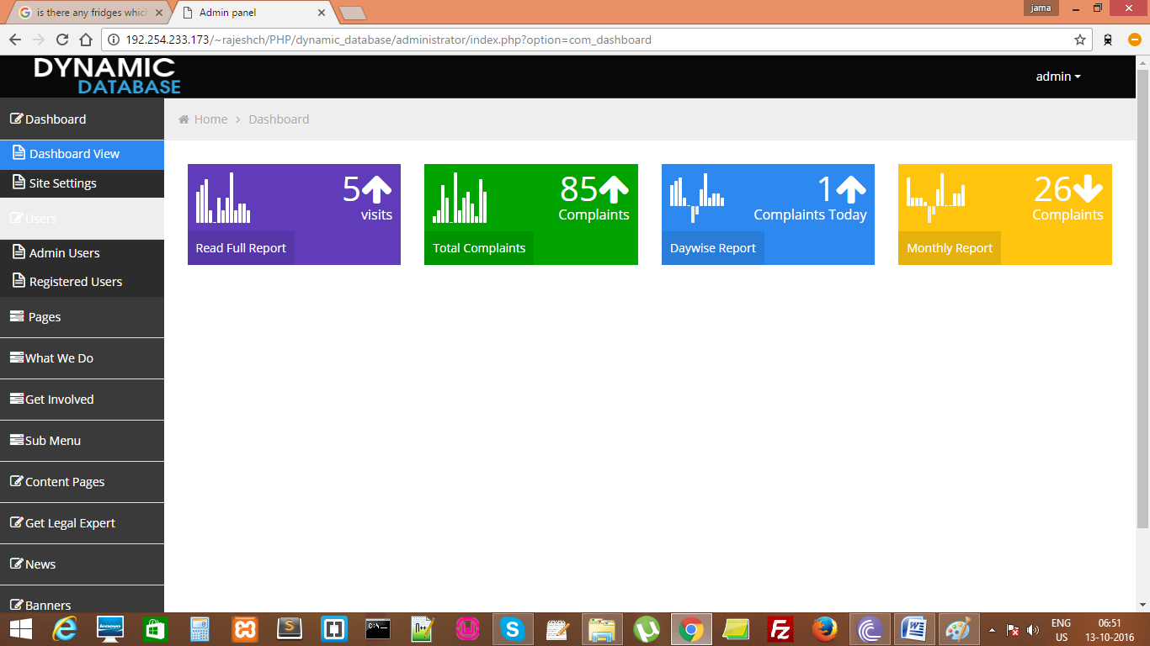

2.To Create, Edit or Delete any complaints or videos, we have to select the tab “Pages”.

It Consists of dropdown have two options namely

a)Complaints b)Videos

We can select the required option and use it.

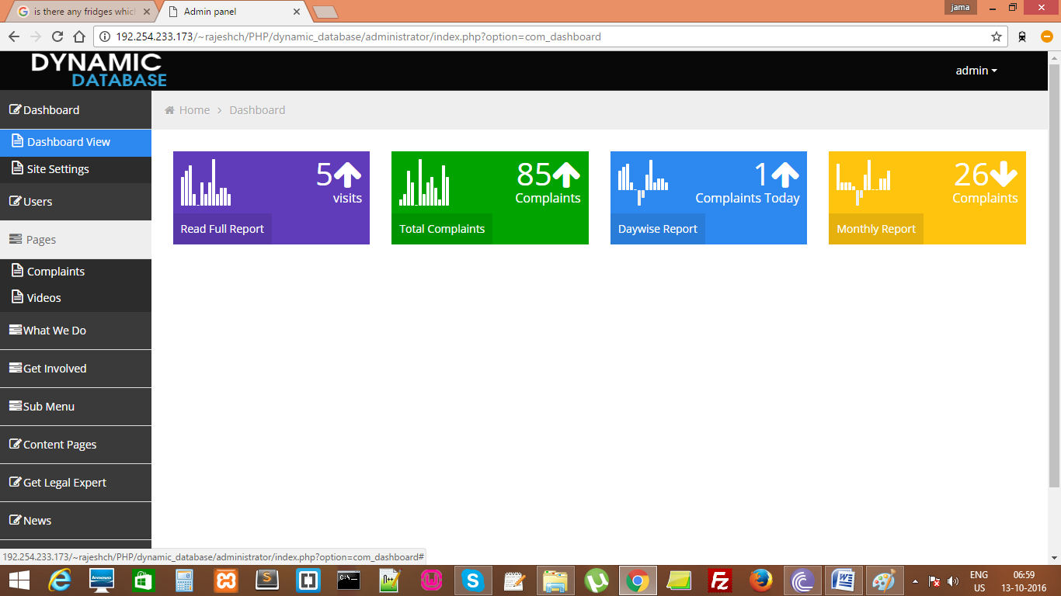

3.”what we do” tab is used to add the content into website menu tab “what we do” tab.

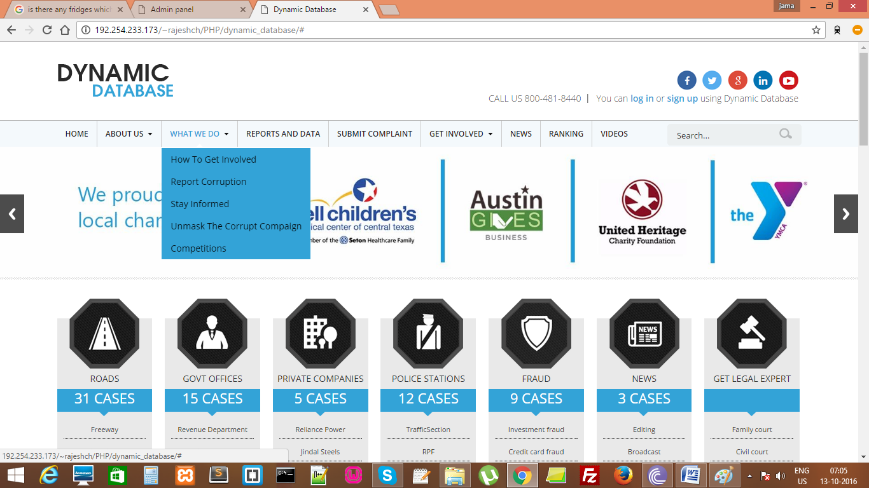

When we add any content from admin panel ,it will display into the dropdown list ,as shown in the above screenshot.

4. ”Get involved” tab is used to add the content into website menu tab “Get involved” tab.

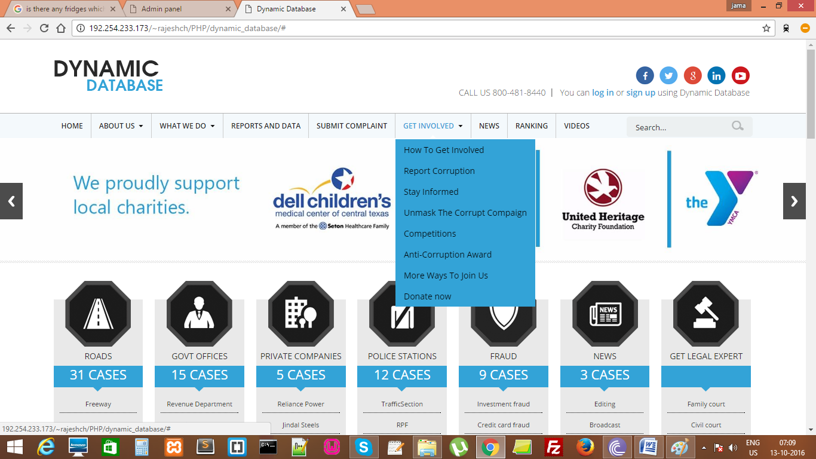

When we add any content from admin panel ,it will display into the dropdown list ,as shown in the above screenshot.

5. ”About Us” tab is used to add the content into website menu tab “About Us”

When we add any content from admin panel , it will display into the dropdown list ,as shown in the below screenshot.

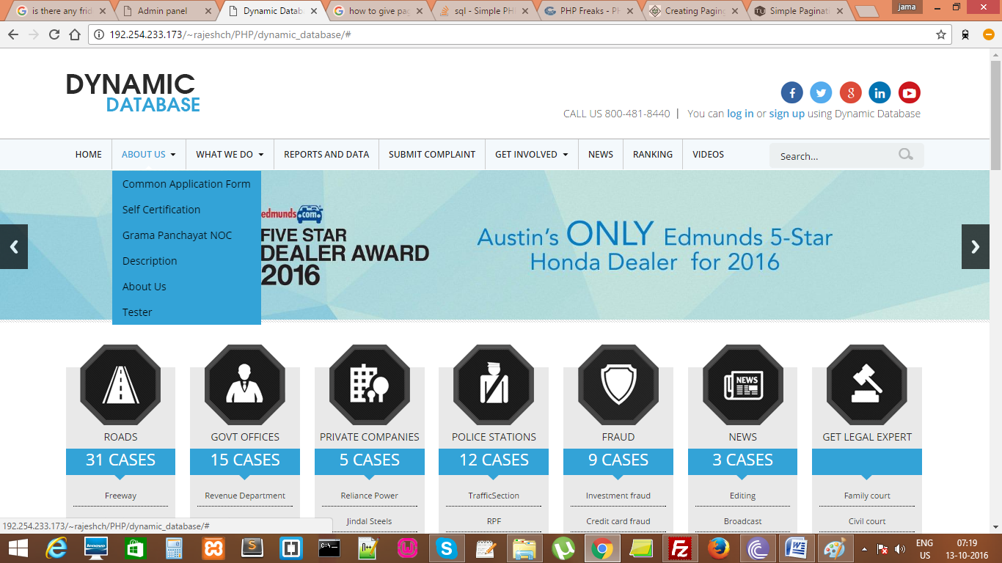

6. “Content Pages tab is used to add the information like “privacy policy” ,”terms and conditions and etc in the website.

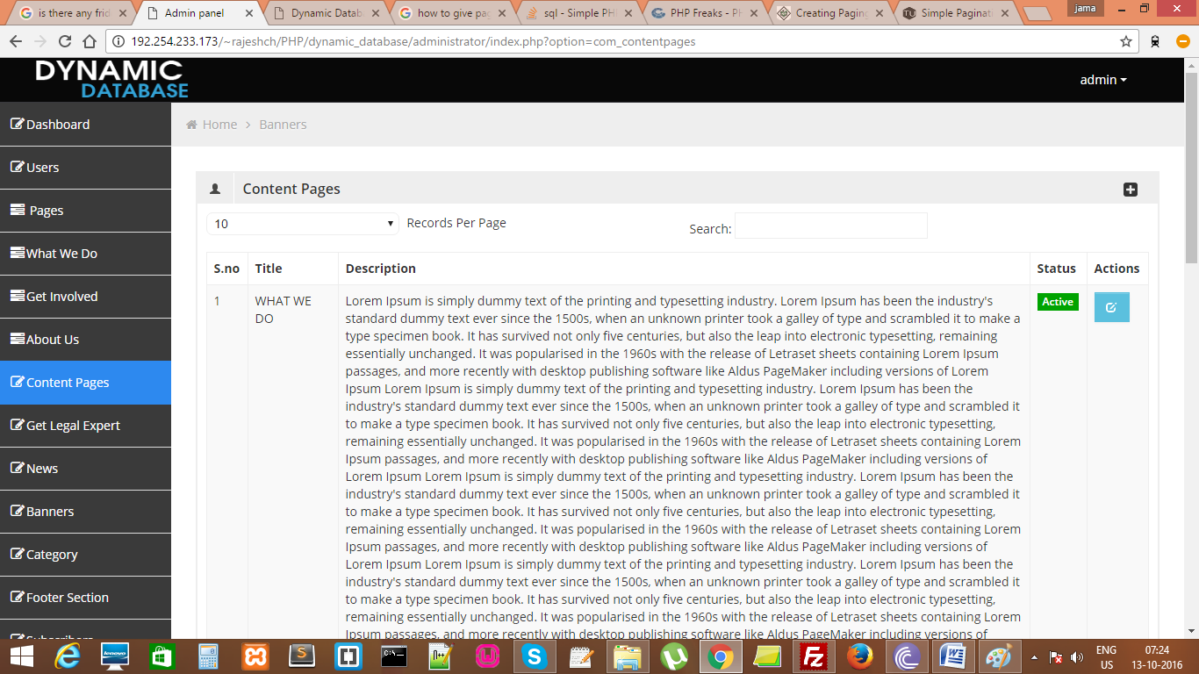

7. “Get Legal Expert” tab is used to add the advocate details in the category named “Get legal Expert”.

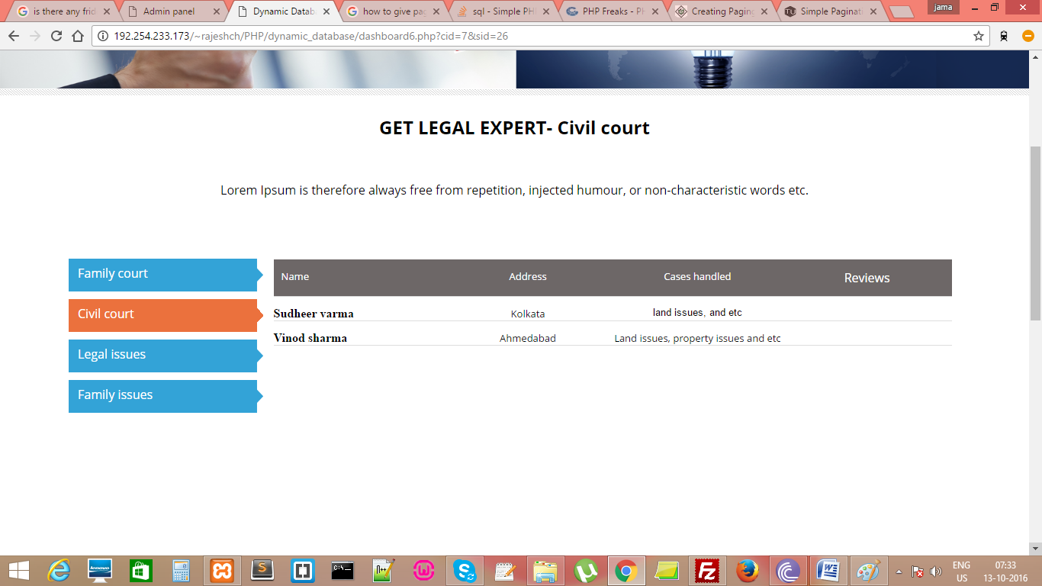

8. In “News” tab we can add, edit and delete the News content.

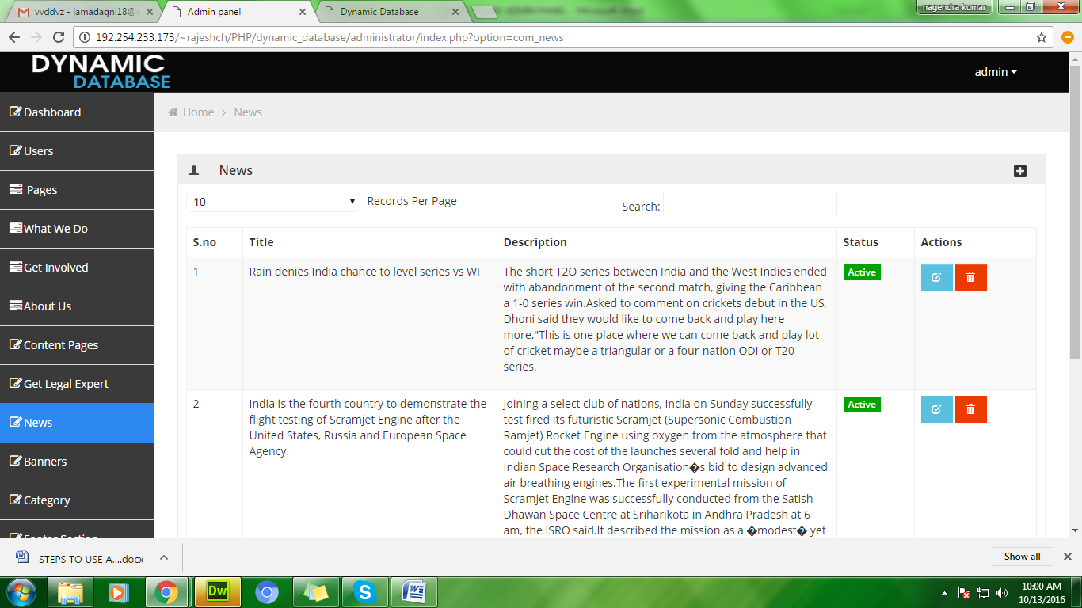

9. In “ Banners” tab we can add/remove and edit the slide images .These are used in the slideshow place in our website home page.

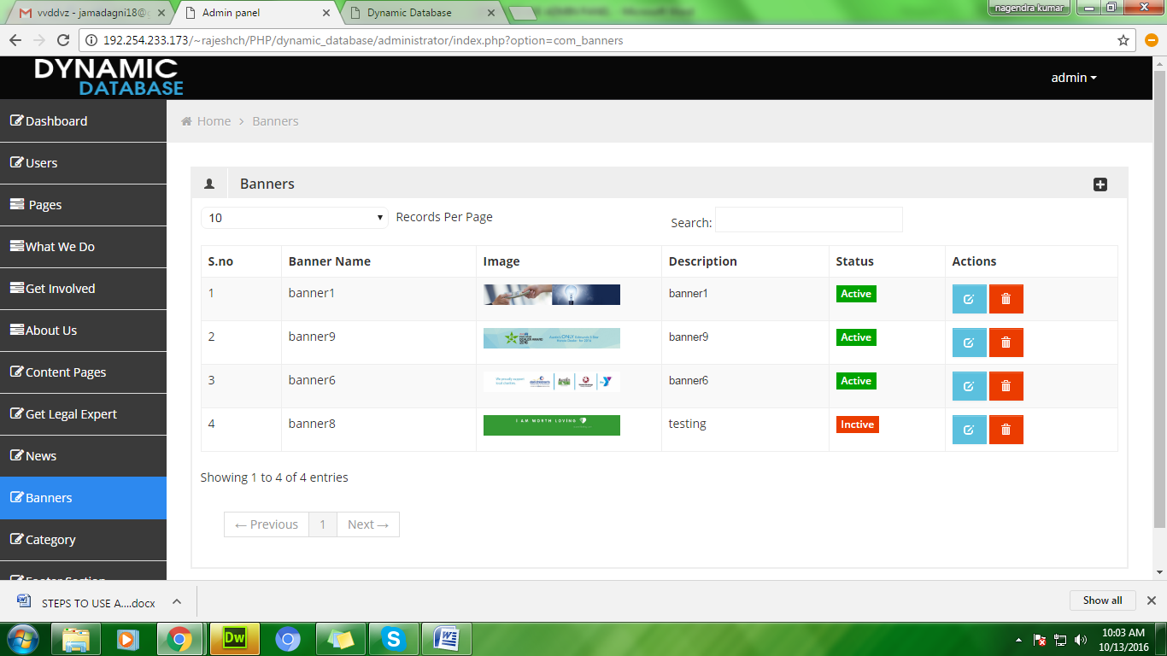

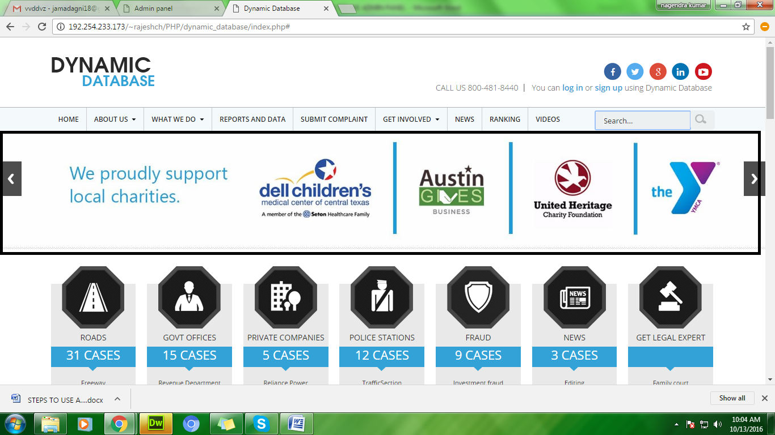

10. In “Category” tab we add/remove the categories present in the website.

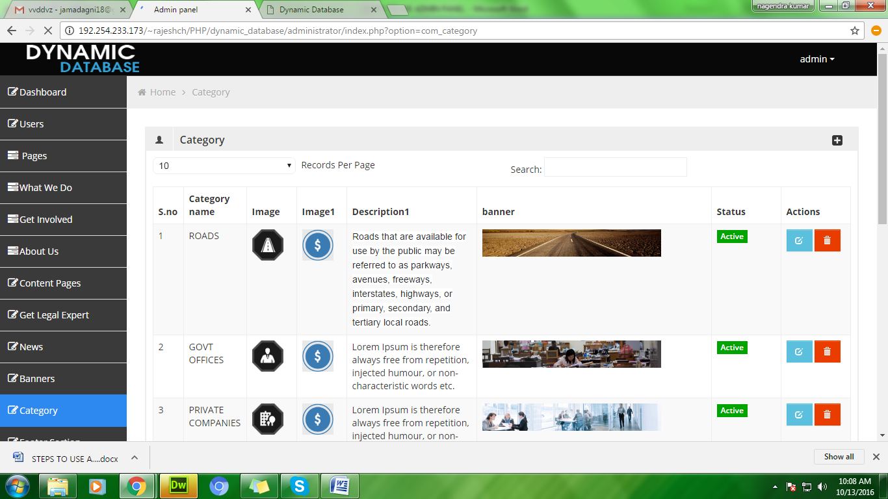

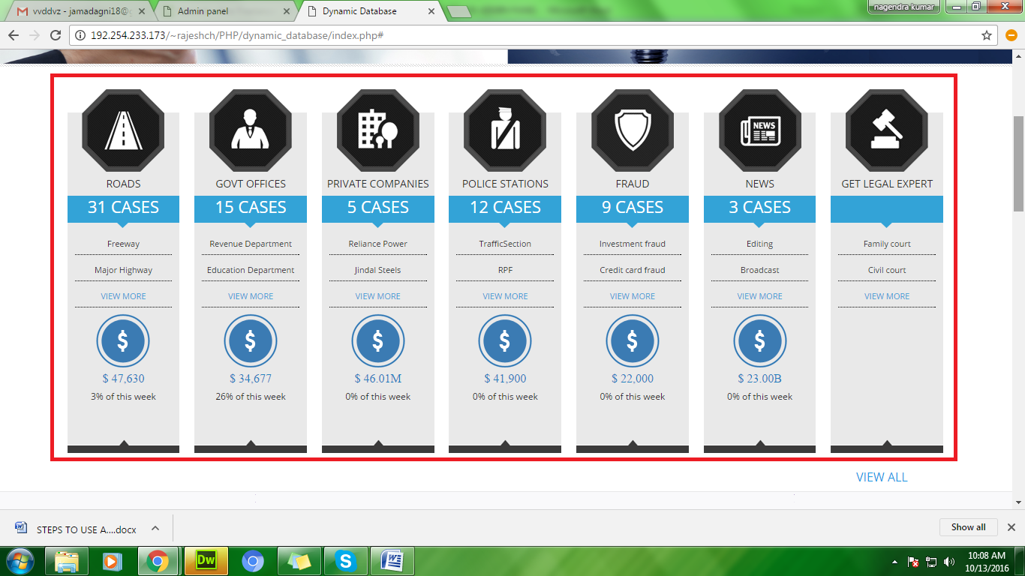

11. In “Subscribers” tab , the list of subscribers added from website will be displayed. From here we add/edit/ remove the records.

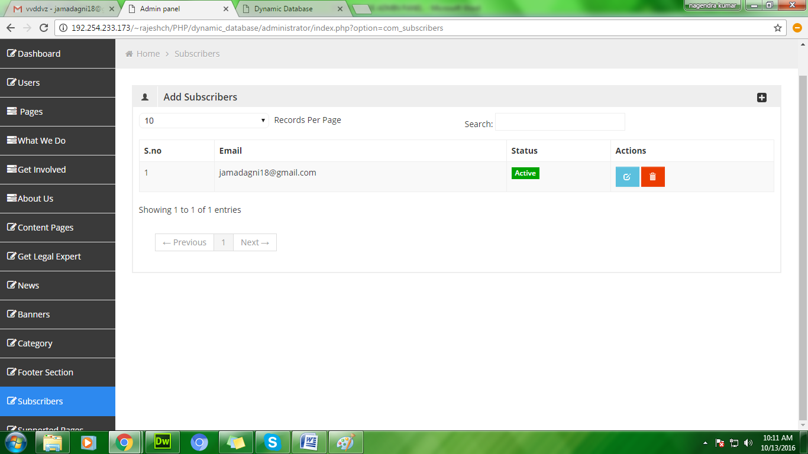

12. In “Supported pages” tab it consists of dropdown with options namely,

a. Country list

b. Department list

c. Sub departments

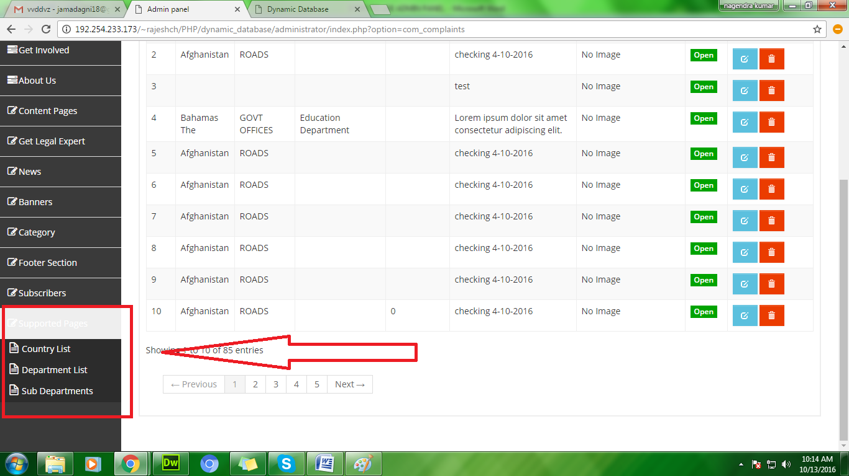

* From “Country list” we can add new countries.
* From “Department List” we can add new sub categories for the main categories present in the website.

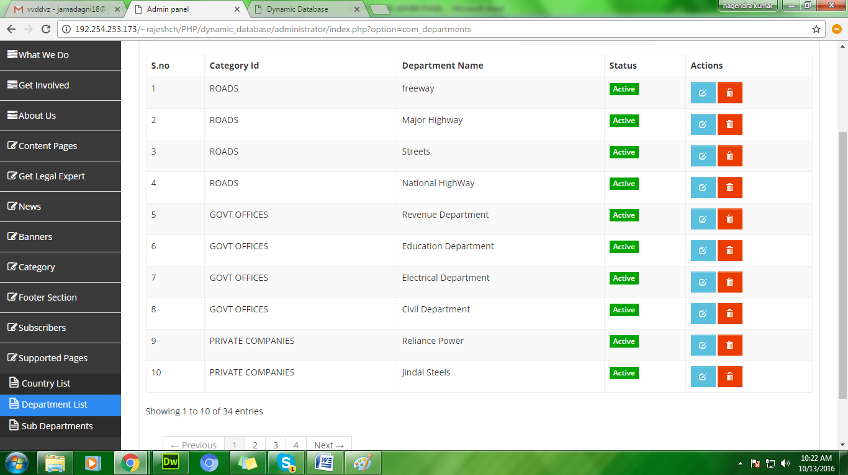

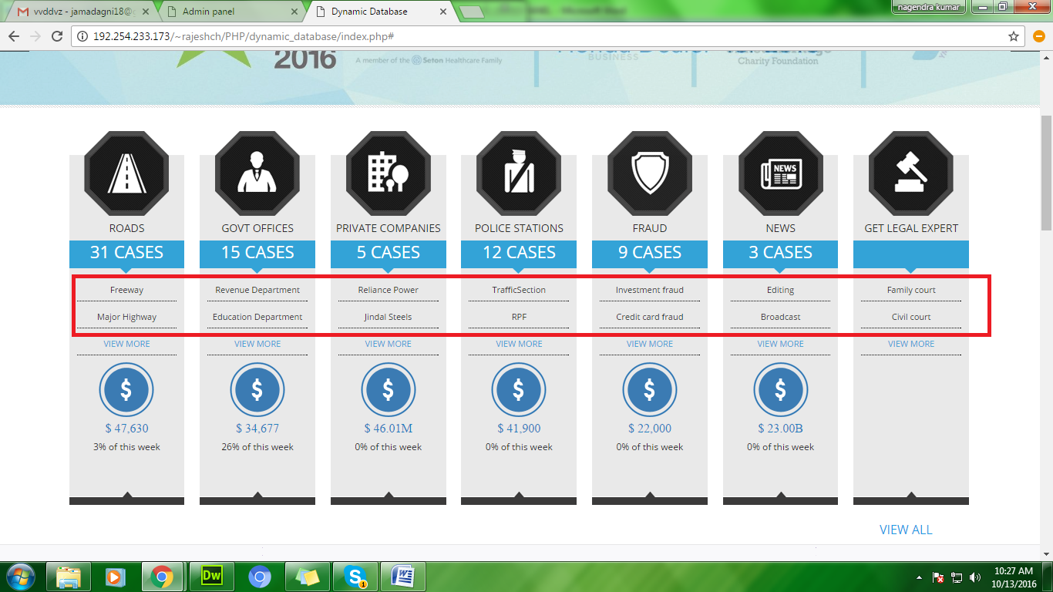

* From “Sub department “ tab we can add sub departments for the department list.

